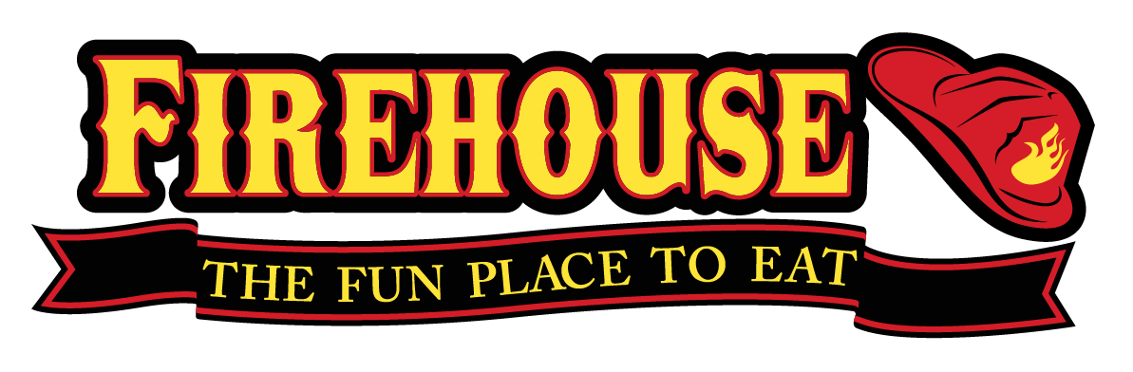
Firehouse Southwest Station
7701 White Lane 661-831-4688
PARTY PLATTERS

Available for large parties and to-go
Brownie Platter…….…………………..…………………………………….……………………$24.99

- 24 Freshly baked Ghirardelli triple chocolate brownies

Sampler Platter (feeds 6-8)…………….………………………………………………………...$36.99

- Choose 3 appetizers to surround our Station Commander Nachos or Flash Point Fries

Chicken Strips Smoky Quesadilla Potato Skins

Cheesy Garlic Bread Onion Rings
Wings Platter ……….……………………..…………………………………….……………………$48.99
- 40 wings with your choice of one sauce; Mild, Hot, 5 Alarm, BBQ, Teriyaki, Sweet and Spicy, Garlic Parmesan or Ghost

Potato Skins Platter …………………..…………………………………….……………………$31.99
- 24 potato skins topped with bacon and cheese, served with sour cream

Crossroad Chicken Strip Platter (feeds 4-6)……………………….…………...………$39.99
- Crispy Chicken tenders served with Ranch dressing

Quesadilla Platter (feeds 10-12)………………………………….………………………………$39.99
- Shredded cheese, pico de gallo, and chicken

Slider Platter (feeds10-12) …….………………………...………..…………..……..….…………$54.99
- 30 mini sliders served on our brioche buns

Sandwich Platter (feeds 8-10) …………….……………………………….…........…….…..…$43.99

- Hook and Ladder - Grilled ham, turkey, and smoked bacon with Swiss and cheddar cheese, lettuce, tomato, and mayo on thick sliced wheat toast
- Turkey Club - Cold Smoked turkey topped with avocado, lettuce, tomato, herb mayo and served on thick sliced whole wheat

Garden Salad Bowl………………………………………………………………………………………$39.99
Your choice of dressings; Ranch, Italian, Balsamic, Honey Mustard, Bleu Cheese or Thousand Island

Caesar Salad Bowl..……………………………….…………..……..........................................$39.99
Romaine lettuce tossed with Caesar dressing and topped with croutons and Parmesan cheese

All menu items are subject to California State Tax. Prices are subject to change.
Firehouse Southwest Station
7701 White Lane 661-831-4688
BACKDRAFT PIZZAS

Indulge yourself with our traditional 12” crust, brushed with garlic butter, and served hot from our ovens

Pepperoni Traditional homemade marinara sauce, topped with mozzarella cheese, and finished with a generous amount of pepperoni $13.99

Veggie Combo Traditional homemade marinara sauce, topped with mozzarella cheese, mushrooms, onions, green bell peppers, black olives, and fresh tomatoes $15.99

Hawaiian Perfectly baked pizza dough topped with our traditional homemade marinara sauce, mozzarella cheese, ham, pineapple, and finished with a sprinkle of parmesan cheese $13.99

BBQ Chicken Sweet and smoky BBQ sauce topped with mozzarella cheese, grilled chicken, cilantro, and red onions $15.99

Meat Lover’s Traditional homemade marinara sauce, topped with mozzarella cheese, smoked bacon, ham, sausage, and pepperoni $16.99

Supreme Combo Traditional homemade marinara sauce, topped with mozzarella cheese, mushrooms, onions, black olives, green bell peppers, sausage, and pepperoni $16.99

Carne Asada Forget marinara, we start with our homemade salsa, topped with jack and cheddar cheese, carne asada, pico de gallo and finished with our house cilantro crème fresh $16.99

BLAZE APPETIZER BUFFET
Priced per person
Not unlimited
20 Person minimum
Party Buffet Includes:

Chicken Quesadilla with Pico de Gallo

Potato Skins

Burger Sliders

Pepperoni Pizza

Wings: Choice of sauce: Mild, Hot, 5 Alarm, BBQ, Teriyaki, Sweet and Spicy, Garlic Parmesan, or Ghost

Priced per person:..……………………………..………………………………………………………. $14.49
All menu items are subject to California State Tax. Prices are subject to change.
Firehouse Southwest Station
7701 White Lane 661-831-4688
LUNCH AND DINNER BUFFET
Priced per person
20 Person minimum

You may select ONE entree for your party

Served with your choice of two Firesides: baked potato, garlic mashed potatoes, seasonal vegetables, steamed broccoli, french fries, coleslaw, or sweet potato fries

Teriyaki Chicken……………………………………………………………………………..…..……… $12.99 Grilled Chicken………………………………………………………………………………………….. $12.99 Grilled Salmon...…………………………………………………………………………………..…….. $15.39
Top Sirloin…………………………..………………………..……..………………………..………….. $13.99

Blackened Chicken Mushroom Alfredo Pasta is a stand-alone entree

Blackened Chicken Mushroom Alfredo Pasta……………….…………………….………………$12.99

Served with rice, beans, salsa, side salad, and dinner roll

Deep Pit Beef………………………………..………………………………..…………..………….......$11.99
Sliced Tri Tip Dinner……………………………………………………..……………………….……..$12.99

Garden Salad Bowl………………………………………………………………………………………$39.99
Your choice of dressings; Ranch, Italian, Balsamic, Honey Mustard, Bleu Cheese or Thousand Island

Caesar Salad Bowl..……………………………….…………..……...........................................$39.99
Romaine lettuce tossed with Caesar dressing and topped with croutons and Parmesan cheese

All menu items are subject to California State Tax. Prices are subject to change.

